

# Design and Simulation of Battery Electric Vehicle using MATLAB Simulink

*A Main Project Report submitted in partial fulfillment of the requirement for the award of degree of*

**BACHELOR OF TECHNOLOGY**

*in*

**ELECTRICAL & ELECTRONICS ENGINEERING**

*Submitted by*

**BUDDEPU HARIKA (20341A0217) GOLLANGI PRAVEEN (20341A0244) BURLA MANIKANTA(20341A0219) BOMMALI MANASA(20341A0215) BARATAM ASHISH(20341A0207)**

*Under the Esteemed Guidance of*

**Dr. G.Chandra sekhar**

Professor, Department of EEE

**DEPARTMENT OF ELECTRICAL & ELECTRONICS ENGINEERING**

(Accredited by NBA, NAAC with ‘A’ Grade & ISO 9001:2008 Certified Institution)

**GMR Nagar, Rajam – 532127, Andhra Pradesh, India.**

**April 2024**



Department of Electrical and Electronics Engineering

# CERTIFICATE

This is to certify that the Main Project report titled “Design and simulation of Battery Electric Vehicle using matlab simulink” submitted by the following students:

**BUDDEPU HARIKA (20341A0217) GOLLANGI PRAVEEN (20341A0244) BURLA MANIKANTA (20341A0219) BOMMALI MANASA (20341A0215) BARATAM ASHISH (20341A0207)**

has been undertaken in partial fulfillment of the requirements for the award of the degree of

Bachelor of Technology in the field of "**Electrical and Electronics Engineering**" at **GMR Institute of Technology**, an Autonomous Institute affiliated with Jawaharlal Nehru Technological University, Vizianagaram. This project work has been conducted under the guidance and supervision of **Dr. G. Chandrasekhar**, who has provided valuable assistance throughout the project duration. The results and findings presented in this report have not been previously submitted to any other University or Institute for the purpose of obtaining any other degree or diploma.

**Signature of the Guide Signature of the HOD**

**Dr. G. Chandrasekhar Dr. P. Ramana**

Professor Professor& HOD

Dept. of EEE Dept. of EEE

GMRIT, Rajam GMRIT, Rajam

# ACKNOWLEDGEMENT

We are immensely pleased to extend our heartfelt gratitude to our guide, **Dr. G. Chandra Sekhar**, **Professor.** in the Department of Electrical and Electronics Engineering, for providing unwavering and invaluable guidance throughout the preparation of this report. Without his persistent and wholehearted efforts, this report would not have reached its current form. His encouragement and support were instrumental in helping us overcome the various challenges we encountered at different stages of the report.

We would like to extend our heartfelt appreciation to **Dr. Rajeshkumar Patnaik**, **Associate Professor** and **Project coordinator**, for offering valuable suggestions and introducing advanced tools that greatly facilitated the project's successful completion.

We extend our sincere gratitude to **Dr. P. Ramana**, **Professor and Head of the Department**, for generously providing all the essential facilities that played a pivotal role in the successful completion of this main project.

We extend our sincere gratitude to our **Principal**, **Dr. C. L. V. R. S. V. Prasad**, and our **Director**, **Dr. J. Girish**, for fostering an environment that facilitated our work. We are truly grateful to them, and their support is something we will always cherish.

Lastly, we would also like to acknowledge the invaluable suggestions and outstanding opportunities extended by the entire department faculty, which significantly contributed to the successful completion of this report. Our heartfelt thanks go out to the department's lab technicians for their direct and indirect support.

**Buddepu Harika (20341a0217) Gollangi Praveen (20341a0244) Burla Manikanta (20341a0219) Bommali Manasa (20341a0215) Baratam Ashish (20341a0207)**

# ABSTRACT

More and more researchers are focusing on the modeling of electric vehicles. One of the most important problems the world's ecosystems are currently confronting is the decrease of greenhouse gas emissions and energy consumption. Even if the actual trajectory of energy is uncertain, we believe that transportation will play a critical role in maintaining it. This study used the MATLAB-Simulink platform to simulate a BEV model and evaluated the various components of the BEV system. MATLAB-Simulink is utilized in this project to develop the BEV components and integrate the entire system. The outputs of this design are the voltage, current, and state of charge values. The car will describe how much energy is discharged when it is traveling and provide information about current and voltage in this project, which is based on voltage, current, and state of charge bases. Utilizing MATLAB-Simulink, it aims to comprehensively model BEV components, including voltage, current, and state of charge, to assess system performance. Through simulation outputs, such as energy discharge during travel, valuable insights into BEV behavior are obtained. The research identifies essential electrical system components and formulates corresponding equations for validation purposes. Additionally, it proposes modeling the future demand for BEVs to further reduce emissions. Selecting appropriate parameters for simulation is pivotal, ensuring accuracy in BEV system modeling. It was also utilized to simulate the BEV model and related formulas. The required electrical system parts were also identified, along with the corresponding equations for validation. To reduce greenhouse gas emissions, we suggested in this project to model the demand for BEVs in the transportation sector going forward. The first step in modeling this is to understand the properties of the parameters and select the appropriate ones for MATLAB simulation of each component. We are also modeling a single app.

**Keywords**: *Battery Electric Vehicle, MATLAB-Simulink, Simulation, Energy consumption,*

# TABLE OF CONTENTS

|  |  |  |  |
| --- | --- | --- | --- |
| **ABSTRACT** | | | **i** |
|  | **List Of Figures** | | **iii** |
|  | **NOMENCLATURE** | | **iv** |
| **CHAPTER-1** | **INTRODUCTION** | | **1** |
|  | 1.1. | Introduction to the Project | 1 |
| **CHAPTER-2** | **LITERATURE SURVEY** | | **2** |
| **CHAPTER-3** | **METHODOLOGY AND PRINCIPLES OF BEV** | | **7** |
|  | 3.1. | Block diagram of BEV | 7 |
|  | 3.2. | Vehicle longitudinal dynamics | 8 |
|  | 3.3. | Motor model | 9 |
|  | 3.4. | Battery charge controller mode | 9 |
|  | 3.5. | Transmission model | 10 |
|  | 3.6. | Simulation parameters | 10 |
| **CHAPTER-4** | **SIMULATION AND RESULTS** | | **14** |
|  | 4.1. | Circuit diagram for simulation | 14 |
|  | 4.2. | Time vs. SOC | 17 |
|  | 4.3. | Time vs. Current | 18 |
|  | 4.4. | Time vs. Voltage | 19 |
|  | 4.5. | Time vs. Distance | 20 |
|  | 4.6. | Time vs. Velocity | 21 |
|  | 4.7. | Challenges and Considerations | 23 |
| **CHAPTER-5** | **CONCLUSION** | | **24** |

REFERENCES

# List OF Figures

|  |  |  |
| --- | --- | --- |
| **FIGURE No.** | **NAME** | **PAGE No** |
| 3.1 | Block diagram of BEV | 7 |
| 3.6.1 | PMDC Motor | 11 |
| 3.6.2 | Lithium ion battery | 12 |
| 4.1 | Simulation circuit of BEV | 14 |
| 4.2 | Sub system of driver input | 14 |
| 4.3 | Sub system of motor and controller | 15 |
| 4.4  4.5  4.6  4.7  4.8  4.9  4.10 | Sub system of battery  Sub system of velocity body and tyres Time vs. SOC  Time vs. Current Time vs. Voltage Time vs. Distance  Time vs. Velocity | 15  15  17  18  19  20  21 |

**NOMENCLATURE**

|  |  |  |
| --- | --- | --- |
| EV | - | Electric Vehicle |
| BEV | - | Battery Electric Vehicle |
| Li-ion | - | Lithium ion battery |
| PMDC | - | Permanent magnet DC motor |
| SOC SOH SRM KM  mi AC WOA DTC  SOE | -  -  -  -  -  -  -  -  - | State of Charge State of Health  Switched Reluctance Motor Kilometers  Miles  Alternating current  Whale optimization algorithm Direct torque control  State of Energy |

# CHAPTER 1 INTRODUCTION

## 1.1. Introduction to the Project

An electric vehicle (EV) is a vehicle type that runs on electrical energy stored in rechargeable batteries or other energy storage devices. It employs one or more electric motors for propulsion. Electric cars primarily run on electricity, as opposed to traditional internal combustion engine vehicles, which burn fossil fuels to provide power. The automotive industry is undergoing a significant transformation, driven by the increasing concerns over environmental sustainability and the need to reduce greenhouse gas emissions. In response to these challenges, there has been a growing interest in the development and adoption of electric vehicles as a cleaner and more sustainable alternative to traditional internal combustion engine vehicles. Among various types of electric vehicles, Battery electric vehicles (BEVs) have gained considerable attention due to their emission operation and potential to significantly reduce dependence on fossil fuels. BEVs rely solely on electric propulsion, utilizing rechargeable batteries as their primary source of energy. This reliance on electricity makes BEVs an attractive option for reducing carbon emissions, particularly when powered by renewable energy sources. The development and optimization of BEVs heavily relies on their design and simulation. The development of simulation tools such as MATLAB Simulink has allowed engineers and researchers to precisely simulate diverse BEV systems and components in order to evaluate how well they function under various operating situations.To reduce energy usage and environmental impact, electric vehicles are becoming increasingly popular for future transportation. Global warming, urban pollution, and the depletion of fossil fuels have heightened tensions worldwide. Over the past century, Internal Combustion Engine (ICE) technology has focused on improving fuel efficiency and lowering pollutants.Before actual prototypes are constructed, this enables iterative design optimizations and upgrades, thereby cutting down on development time and expenses. In this research, we use MATLAB Simulink to build and simulate a battery-electric car. Our goal is to give a thorough rundown of the modelling procedure, including important elements such the electric motor, battery pack, power electronics, and vehicle dynamics.

# CHAPTER 2 LITERATURE SURVEY

### Kaushik, Shivangi, Modeling and Simulation of Electric Vehicle to Optimize Its Cost and Range,International Journal of Engineering and Advanced Technology (IJEAT)

**,August 2019.**

In this paper presents concentrate on the analysis and optimization of battery-electric vehicles (BEVs) using mathematical modeling, simulation-based parameter evaluations, and energy consumption analysis. They seek to determine the best setups and settings in order to improve BEV performance, efficiency, and sustainability. Without doing a lot of actual testing, researchers investigate ways to increase battery efficiency, range, and overall vehicle performance using simulations and mathematical models.

These studies offer insightful information that will help advance BEV technology and advance environmentally friendly transportation.EV wheel drive system with separate front and rear control enhances EV performance, including torque and speed stability, steering ability, drivability, and safety during low and high-speed operations. Furthermore, the wheel drive systems were designed such that the EV performance standards listed above could be met more efficiently. The drive systems are coordinated so that if front wheel drive torque is inadequate to move the EV at specified speeds, the rear wheel drive system can give appropriate torque. This work uses typical un-optimized PI controllers to synchronize and control the drive system.

Then later on WOA (Whale Optimization Algorithm) combined with DTC(Direct torque control) improves drive controller performance. The simulation results demonstrate the efficiency of using optimization over PI controllers. The optimized EV system model immediately achieves consistent speed and torque in both beginning and normal running modes. WOA optimization provides more accurate findings than unoptimized controls. Thus, the deployment of WOA in an EV wheel drive control system has been effective.

### Aniket Vinod ,G H Raisoni, G H Raisoni ,Simulation for Battery Electric Vehicle usingMATLAB,International Journal for Research in Applied Science and Engineering Technology, 2021.

In this paper studies provides a comprehensive overview of various strategies for portraying electric car use over time, with a focus on significant differences between the techniques used. We recommend movement-based displaying (ABM) for seasonal interest analysis due to its ability to accommodate integrated move-place investigations and the growing convergence of the car and electricity communities. Electric vehicles (EVs) are seen as a solution to the issue of rising fossil fuel emissions and dependence on petroleum derivatives. The adoption of electric vehicles (EVs) is hindered by anxiety, long charging times, and inadequate charging infrastructure.

### A. A. Abulifa, R. K. R. Ahmad, A. C. Soh, M. A. M. Radzi and M. K. Hassan, Modelling and simulation of battery electric vehicle by using MATLAB- Simulink, IEEE 15th Student Conference on Research and Development (SCOReD)2017.

This paper presents a simulation of BEV, including its electrical system components and verification equation. Additionally, it evaluates all simulation results. BEV components include transmission, electric motor, battery charge controller, driving cycle, driver model, and longitudinal vehicle dynamics model. This simulated BEVs and their components to assess energy flow, performance, and efficiency. MATLAB-Simulink provided accurate findings for battery voltage, current, power, and state of charge. There are many opportunities to improve the BEV model, which will serve as a foundation f

### Tengku Mohd, Tengku Azman & Hassan, Mohd Khair & Aris, Ishak &che soh, Azura &Ksm Kader Ibrahim, Babul Salam & Hat, Mohd Kamal,Simulation based study of electric vehicle parametersARPN Journal of Engineering and Applied Sciences,,2015.

The paper provides consistent battery capacity for various electric car segment criteria. The study suggests that electric vehicles need to be lightweight and compact for optimal fuel efficiency. Smaller automobile segments lead to improved performance and energy consumption.

Small electric vehicles with smaller batteries are ideal for urban commuting due to weight and space limits, and can benefit from regenerative braking. To extend battery life, higher-capacity cars should be driven on highways with a lower discharge profile. Conventional segmentation (i.e. by dimension) is extremely incorrect for electric vehicles; compact EVs may operate faster and have a longer range than large EVs

due to their traction batteries. As such, electric vehicle segmentation should be based on range and speed. Nonetheless, automotive segment is not the sole consideration while designing an electric vehicle. Several criteria may conflict and require trade-offs to be made. Furthermore, researchers are increasingly interested in motor control and energy management systems. This study compares the battery capacity of electric vehicle models across different segments.

### -Simulink Dhanashree Joshi, Gayatri Kulkarni, Kanchan Wakode , Samiksha Thool, Shreya Parkhe, Vaishnavi,Simulation of Battery Electric Vehicle by Using MATLAB,International Journal of Advanced Research in Science, Communication and Technology (IJARSCT) Volume 2, Issue 8, May 2022.

This paper Energy adaptation proficiency The expense of an electric vehicle exceeds that of a conservative vehicle's ability to adapt to electricity. The battery will be a reliable energy source. The model simulation will show how a battery behaves and how it charges when broken. Building a Simulink model has various advantages. The model simulation will show battery behaviour, including how breaking the batteries recharge it. The computer model below shows how electric car components function, how they are organized, and how we may achieve optimal performance. MATLAB-Simulink is used to plan BE modules and integrate the system in this work. It also does simulations of the BEV model and its accompanying equations. Authentication requires a certain equation. It also summarizes all of the simulation outcomes. BEV components include the transmission, electric motor, battery charge controller, driving cycle, driver model, and longitudinal vehicle dynamics model.

### A. Bhatt, Planning and application of Electric Vehicle with MATLAB, IEEE International Conference on Power Electronics, Drives and Energy Systems (PEDES), Trivandrum, India, 2016.

This paper introduces Vehicle emissions have a significant impact on global warming. Several countries have focused on developing alternative fuel technology. Battery power is the most promising option for powering electric vehicles now and in the future. Global automobile manufacturers are investing considerably in research into battery-powered, efficient electric vehicles. The simulation model includes EV recovery capabilities. Simulation results were analyzed for various vehicle velocity inputs and summarized in terms of vehicle range and battery state of charge (SOC). This article

concludes with an evaluation and summary of vehicle range and SOC based on input parameter variations. This summary can provide valuable insight to expand the scope of this EV.

### Aloko, B. Sri, Mauridhi Hery Purnomo Soebagio, and M. Hery Purnomo. Design and development of small electric vehicle using MATLAB/Simulink,International Journal of Computer Applications ,June 2011.

This paper introduces the issue of global oil depletion, as well as the problem of air pollution caused by motor vehicles, has prompted numerous researchers to seek alternate energy sources to move automobiles. One promising solution is to replace the combustion motor with an electric motor, resulting in an electric vehicle. The first stage of this research is to model the flow of power in the electric vehicle energy system to determine its properties. Electric vehicles rely heavily on limited electrical energy from batteries, making power flow efficiency crucial. Therefore, it requires adequate management.

### Saldaña, Gaizka, Analysis of the current electric battery models for electric vehicle simulation,International Mechanical Engineering Congress & Exposition. (2019).

The paper introduces Battery models can be divided into three categories: electrochemical models, mathematical models, and electrical models. Electrochemical models are the most precise at replicating all internal phenomena. However, they require a lot of processing resources and are extremely slow. As a result, they are appropriate for battery design but not for real-time control or simulation applications. Mathematical models are appropriate for particular calculus or forecast parameters, such as statistical cycle life based on experimental

These models are suitable for transient state investigation, although the AC response is limited. Impedance models are suited for AC response analysis since they are constructed in the impedance domain. However, their temporary status Response is really restricted. Runtime models provide both DC and runtime responses while maintaining an average fixed current. Finally, coupled models combine the models' advantages, increasing accuracy while decreasing simulation speed.

The estimation of the parameters is another critical component. While factors like SoC and SOH must be measured online, the parameters can be estimated offline and modified online if necessary. If an offline assessment of SOC or SOH is made based on laboratory experiments,

and the parameters are not related to the real cycling of the battery, the results will be inaccurate

### PChatterjee, J Singh, R Singh , Y A R Avadhand S Kanchan,IOP Conference Series: Materials Science and Engineering,Electric Vehicle Modeling in MATLAB and Simulink with SOC &SOE Estimation of a Lithium-ion Battery.

The paper about enhance the energy storage management system of an electric vehicle, we tracked precise battery statuses. We developed many models for BMS management, thermal modelling, thermal characteristics, and EV modelling. We obtained simulation findings by utilizing several drive cycle sources and running models across various time periods. Graphs and displays vary, leading to varied conclusions on how different parameters impact electric car performance and efficiency.

Our technique for estimating SOC and SOE is simple and integrated. This technique simplifies the assessment of battery SOC and SOE in BMS, eliminating the need for complex processor computations.

### Cuma, Mehmet Ugras, and Tahsin Koroglu. A comprehensive review on estimation strategies used in hybrid and battery electric vehicles,ScienceDirect,(2015).

This paper introduces in recent years, there has been a surge of global interest in hybrid and battery electric vehicles due to their ability to reduce fuel consumption, reduce reliance on imported oil, and reduce greenhouse gas emissions. The total success of these vehicles is largely dependent on the performance of the sub-systems for which they are designed. To improve the performance of these subsystems, accurate parameter estimate is essential. Furthermore, estimate methodologies contribute significantly to battery management, vehicle energy management, and vehicle control by performing a variety of tasks. There have been few review studies on estimation methodologies that focus solely on battery state of charge (SOC) and state of health (SOH) estimation.

This study provides a complete assessment of the various estimating methodologies used. in hybrid and battery electric vehicles for the first time in the literature. The existing estimation strategies are classified and different methodologies used in each estimation strategy are elaborated.

# CHAPTER 3 METHODOLOGY AND PRINCIPLES OF BEV

The BEV and its components were recreated to investigate energy flow, performance, and efficiency. MATLAB-Simulink shows battery voltage, current, and state of charge information. The goal is to optimize the battery's voltage, current, potency, state of charge, and component size while minimizing energy consumption using modelling and simulation. **3.1.Block diagram of BEV:**

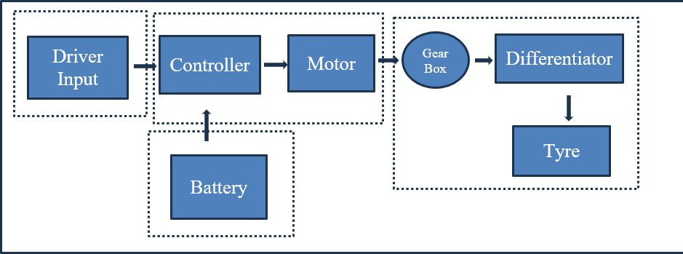

*Fig.3.1 Block diagram of Battery Electric vehicle*

### Driver input:

Overall, BEVs offer a simpler and more focused driving experience compared to gasoline vehicles, with an emphasis on steering, braking, and acceleration control.

**Controller:**

In a Battery Electric Vehicle (BEV), the controller acts as the brains behind the operation, managing the flow of energy between the battery and the electric motor. It essentially translates driver input into motor action and optimizes performance.It ensures efficient and smooth operation, maximizing range, responsiveness, and safety.

**Motor:**

The electric motor is the heart of a Battery Electric Vehicle (BEV), responsible for converting electrical energy stored in the battery into mechanical energy that propels the vehicle. There are several types of electric motors used in BEVs. They are PMDC, induction motor(AC), SRM etc we choose according to our use.

**Gear box:**

Overall, gearboxes play a crucial role in controlling and managing the flow of mechanical power in various applications. They provide the necessary adjustments in speed, torque, direction, and power distribution to meet the specific needs of the machine.

### Differentiator:

Differentiators have various applications in electronic circuits, including: Signal processing: Extracting specific features from signals, such as edges or high-frequency components.

Control systems: Implementing feedback mechanisms based on the rate of change of a signal (e.g., speed control systems).

**Tyres:**

Regardless of whether you choose specific BEV tyres or high-quality regular tyres, always ensure they meet the size, speed rating, and load rating specifications recommended by your BEV's manufacturer for optimal performance, safety, and efficiency.

**Battery:**

This crucial system monitors the battery pack, including voltage, current, temperature, and cell health. The BMS performs several functions: Ensures safe operation by preventing overcharging or overheating. Balances the individual cells within the pack to maximize performance and lifespan. Provides data on battery health and remaining charge.

### Vehicle Longitudinal Dynamics:

The longitudinal dynamics of a Battery Electric Vehicle (BEV) refer to the forces and motions that cause the vehicle to accelerate and decelerate along its route of travel. This covers things like traction force, air resistance, rolling resistance, and braking force. Understanding these dynamics is critical to improving the vehicle's performance, energy efficiency, and overall driving experience.For the evaluation of longitudinal nature of electric vehicles some equations are used. The Electric vehicle model based on motion resistance forces like an aerodynamic drag, rolling and climbing resistance and vehicle velocity. For example, longitudinal dynamics have a considerable impact on the vehicle's range, which is a major concern for BEVs due to limited battery capacity. The longitudinal dynamics are

influenced by factors such as vehicle mass, aerodynamics, tire properties, and electric powertrain efficiency.

𝑀 𝑑𝑦 = (𝐹

+𝐹

)-(𝐹

+ 𝐹

+ 𝐹

+ 𝐹

) ……………………(1)

𝑑𝑥

𝑡𝑓

𝑡𝑟

𝑟𝑓

𝑟𝑟

𝑎𝑑

ℎ𝑐

where M is the vehicle mass, 𝑑𝑦is the linear acceleration of the vehicle along the longitudinal

𝑑𝑥

direction. 𝐹𝑡𝑓 and 𝐹𝑡𝑟 is the traction force of the front and rear tires, 𝐹𝑟𝑓 𝑎𝑛𝑑 𝐹𝑓𝑓s the rolling resistance force of the front and rear tires, 𝐹𝑎𝑑 is the aerodynamic drag force and 𝐹ℎ𝑐 is the hill climbing force.

### Motor model

There are many ways to measure motor speed, including instructions and voltage. The equation clearly indicates that it is an input to the motor controller.

𝑊𝑣 = 𝛼𝑈 + 𝑏

Where U is the characteristic curve that approximates a line, V is the motor speed regulation instruction voltage, and a and b are the equation coefficients that differ with the motor load. The motor model is based on a dc motor with a stiff rotor and shaft. Friction torque is proportional to shaft angular velocity.

𝑑2𝜃 1

𝑑𝜃

𝑑𝑡2 = 𝐽 (𝐾𝑡𝑖 − 𝑏 𝑑𝑡 ) ……………………………..(2)

𝑑𝑖

𝑑𝑡

1

= 𝐿 (−𝑅𝑖 + 𝑉 − 𝐾𝑒

𝑑𝜃

𝑑𝑡

) …………………………(3)

here 𝑑𝜃 is the angular velocity, 𝑑2𝜃 is the angular acceleration,𝑑2𝜃 is the moment of inertia, b

𝑑𝑡

𝑑𝑡2

𝑑𝑡2

is the motor viscous friction constant, 𝐾𝑡is the motor torque constant, 𝐾𝑒 is the electromotive force constant.

The DC motor model depicts the motor's electromechanical characteristics. This encompasses torque-speed characteristics, efficiency, and power output. Typically, DC motors are represented by equations that characterize their electrical and mechanical characteristics.

### Battery Charge Controller Mode:

The longevity of the batteries is due to this tool. It is crucial for developing the electric system of a BEV with an efficient Battery Management System (BMS). The State of Charge (SoC), measurement, cell balancing, battery voltage, current, and temperature are all displayed by the BMS. This model covers a basic battery pack and is based on the IRIZ battery.

The battery's overall charge is simply deducted from the motor's current draw. Next, the battery's voltage output is obtained using a typical discharge graph plot. The charge state (SOC) is

SOC =

Cmax − Cused Cmax

### Transmission model

The transmission model translates torque from motor model and braking force from driver model into front and rear traction forces. These forces are the inputs to the longitudinal vehicle dynamic model. The braking force𝐹𝑏, can be expressed as:

𝐹 𝑇𝑑

-------(4)

𝑏= 𝑟𝑑

where 𝑇𝑏is the braking torque and 𝑟𝑑 is the radius of wheel.

The transmission model of a Battery Electric Vehicle (BEV) is a crucial component that manages the vehicle’s power requirements during gear changes. It transfers torque from the engine model and braking force from the driver model to the front and rear traction forces. The model includes several parameters such as rotor inertia of the Motor Generator (MG) rotor, vehicle mass, transmission ratio, tire radius, derivative of MG rotation speed, torque developed by MG, output of Power Split Device (PSD) torque, and resultant torque.

### 3.6 Simulation parameters:

Permanent magnet DC (PMDC) motors offer several benefits when used in battery electric vehicles (BEVs):

1. High Efficiency: PMDC motors are known for their high efficiency, which is crucial in electric vehicles to maximize range and minimize energy consumption. Their simple design and direct current operation contribute to this efficiency.
2. Compact Size and Lightweight: PMDC motors tend to be smaller and lighter than other types of motors with comparable power output. This is advantageous in BEVs, where reducing weight and maximizing space efficiency are priorities for extending range and improving performance.
3. High Power Density: PMDC motors have a high power density, meaning they can deliver a lot of power in a relatively small package. This is beneficial in electric vehicles where space is limited and every component needs to be optimized for performance.
4. Regenerative Braking Compatibility: PMDC motors are well-suited for regenerative braking systems commonly used in electric vehicles. During braking, the motor can act as a generator, converting kinetic energy back into electrical energy and storing it in the battery for later use, thus improving overall efficiency and extending range.
5. Instant Torque: PMDC motors provide instant torque, delivering strong acceleration from a standstill, which enhances the driving experience in electric vehicles. This characteristic is particularly advantageous in urban driving conditions where quick acceleration and responsiveness are important.
6. Reliability and Durability: PMDC motors have a simple construction with fewer moving parts compared to other types of motors, resulting in greater reliability and durability. This is beneficial for electric vehicles, as it reduces the likelihood of mechanical failures and maintenance requirements, contributing to lower operating costs over the vehicle's lifetime.

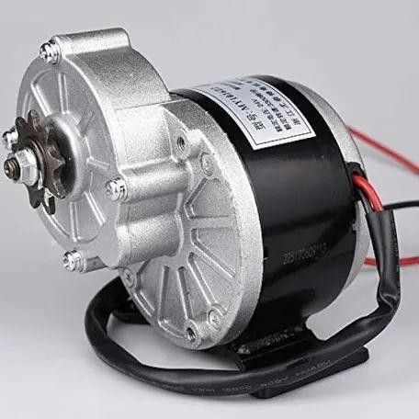

*Fig.3.6.1. PMDC Motor*

Overall, the high efficiency, compact size, regenerative braking compatibility, instant torque, reliability, and cost-effectiveness of PMDC motors make them well-suited for use in battery electric vehicles, contributing to improved performance, range, and overall driving experience.

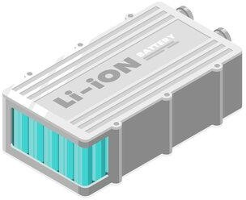

*Fig.3.6.2.Lithium ion battery*

Lithium-ion batteries are the most common type of battery used in battery electric vehicles (BEVs) for several reasons:

1. Energy Density: Lithium-ion batteries offer high energy density, meaning they can store a large amount of energy in a relatively small and lightweight package. This is crucial for electric vehicles, as it allows for longer driving ranges without significantly increasing the weight or size of the battery pack.
2. Power Density: In addition to energy density, lithium-ion batteries also have high power density, allowing them to deliver the necessary power for acceleration and sustained driving performance. This contributes to the responsiveness and agility of electric vehicles.
3. Fast Charging: Lithium-ion batteries can be charged relatively quickly compared to other types of batteries, especially when equipped with fast-charging technology. This reduces charging times and enhances the convenience of owning and operating electric vehicles.
4. Long Cycle Life: Modern lithium-ion batteries have a long cycle life, meaning they can withstand a large number of charge-discharge cycles before experiencing significant degradation in performance. This is important for the longevity and reliability of electric vehicles, as it reduces the need for frequent battery replacements.
5. Maintenance-Free: Lithium-ion batteries require minimal maintenance compared to other types of batteries, such as lead-acid batteries. They do not require periodic watering or equalization charging, which simplifies the ownership experience for electric vehicle owners.
6. Environmental Impact: Lithium-ion batteries have a lower environmental impact compared to fossil fuel-powered vehicles when considering their entire lifecycle, including manufacturing, use, and disposal. However, it's important to address issues related to responsible sourcing of raw materials and recycling of spent batteries to minimize environmental impact further.

### Working Of Lithium-ion Battery:

The lithium-ion battery works on the basis of circulating electrons through the creation of a potential difference between two electrodes, one positive and the other negative, submerged in an electrolyte, a conductive ionic liquid.

Regarding the lithium-ion battery, its nomenclature comes from the fact that it operates on lithium ions (Li+). A lithium-ion battery, like the one found in the ZOE, is made up of several battery units, or cells, that are coupled to one another and are under the control of a certain electronic circuit. The battery's capacity, or the total quantity of electricity it can store, is determined by the number, size, and arrangement of its cells as well as the voltage it delivers.

In the automotive sector, this is typically expressed in watt-hours (Wh) or kilowatt- hours (kWh).

Overall, the combination of high energy density, fast charging capabilities, long cycle life, low maintenance requirements, and compatibility with renewable energy sources makes lithium-ion batteries an ideal choice for powering battery electric vehicles, driving the transition towards cleaner and more sustainable transportation solutions.

# CHAPTER 4 SIMULATION AND RESULTS

## Circuit diagram for simulation:

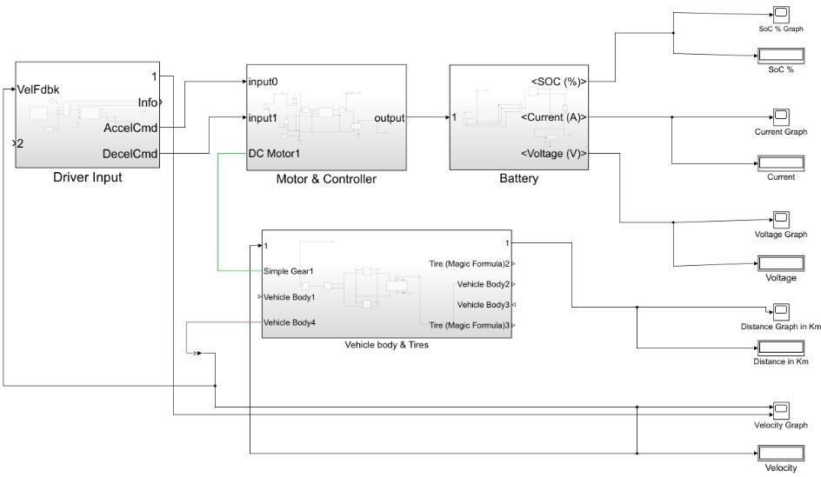

*Fig.4.1. Simulation circuit of BEV*

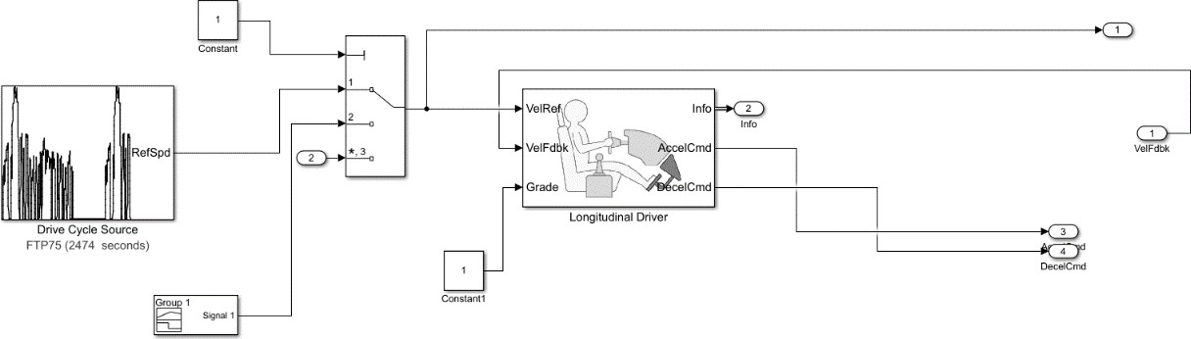

*Fig.4.2. Sub system of Driver input*

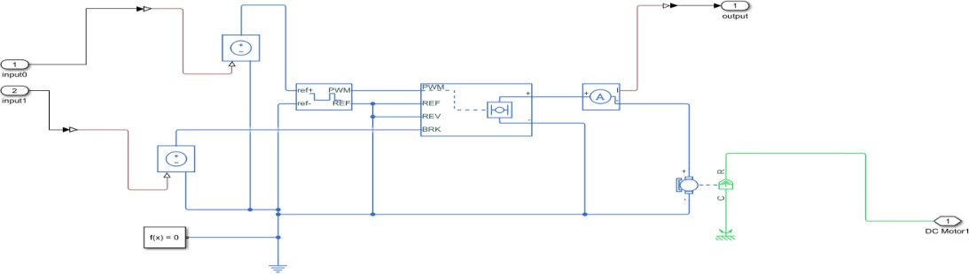

*Fig.4.3. Sub system of motor and controller*

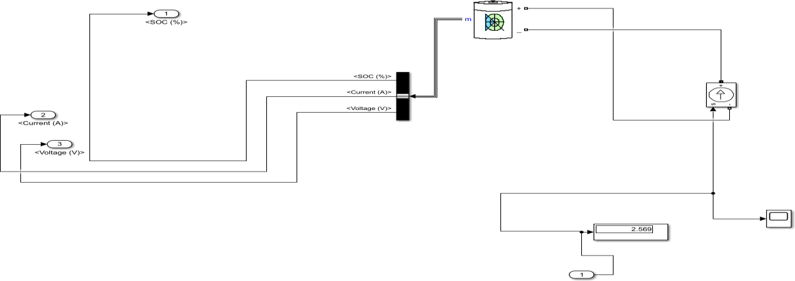

*Fig.4.4. Sub system of battery*

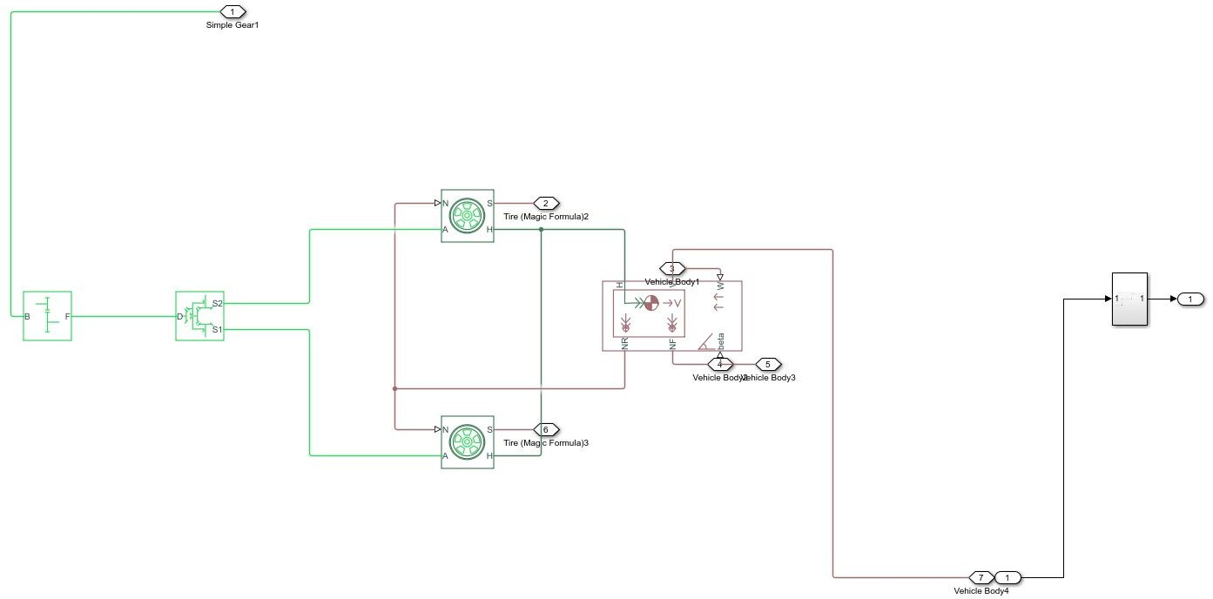

*Fig.4.5. Sub system of velocity body and tyres*

The circuit diagram shows how the different parts of the system interact with each other. For example, the driver input block sends signals to the motor controller, which controls the speed and direction of the motor. The motor controller also receives information from the battery block, such as the current and voltage, which it uses to control the amount of power that is delivered to the motor. The velocity graph shows the speed of the vehicle, which is determined by the motor speed and the gear ratio.

The main parts of the system are:

* SOC: This block calculates the state of charge (SOC) of the battery. The SOC is an important metric for EVs, as it indicates how much energy is remaining in the battery.
* Driver Input: This block represents the input from the driver, such as the acceleration and deceleration commands.
* Motor & Controller: This block controls the electric motor of the vehicle. The motor controller takes the input from the driver and converts it into a signal that can be used to control the speed and direction of the motor.
* Battery: This block represents the battery that powers the vehicle.
* Simple Gear: This block represents the gear ratio of the vehicle. The gear ratio is the ratio of the speed of the motor to the speed of the wheels.
* Tires (Magic Formula): This block represents the tires of the vehicle. The magic formula is a mathematical model that is used to simulate the behavior of tires.
* Vehicle Body: This block represents the body of the vehicle. The vehicle body includes the chassis, suspension, and wheels.

This is a simplified circuit diagram of an EV system. There are many other factors that can affect the performance of an EV, such as the weather, the terrain, and the weight of the vehicle.

## Time vs. SOC

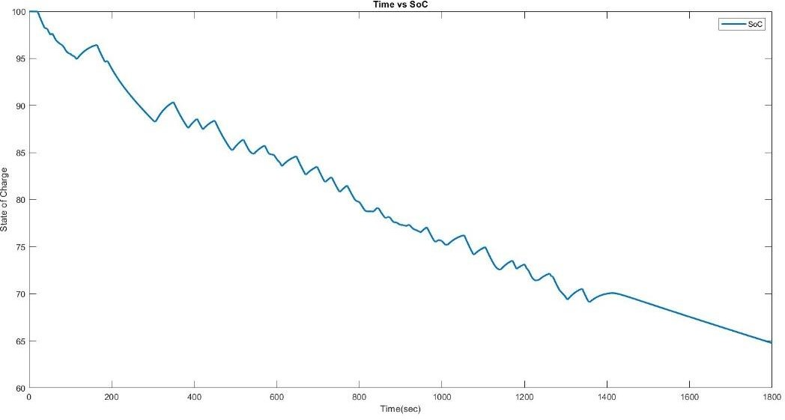

*Fig.4.6.Time vs. SOC*

Time and state of charge (SOC) are both important for understanding battery health and usage, but they represent different things:

* Time: This is simply the duration for which a battery has been used or charged. It doesn't directly tell you how much usable energy is left in the battery.
* State of Charge (SOC): This is a measurement of the remaining capacity in a battery relative to its full capacity. It's usually expressed as a percentage (0% = empty, 100% = full). SOC is crucial because.
* Optimal Performance: Overcharging or undercharging can damage batteries and shorten their lifespan. Knowing the SOC helps you maintain the ideal range for best performance.
* Safety: Overcharged batteries can become unstable and potentially hazardous. SOC monitoring helps prevent this.
* Range Estimation: In electric vehicles (EVs), SOC is like a fuel gauge, indicating how far you can travel on the remaining charge.

While time plays a role in SOC, it's not a perfect measure. Several factors can affect how quickly a battery discharges over time:

* Discharge Rate: The higher the current a battery supplies, the faster its SOC decreases.
* Temperature: Extreme temperatures can accelerate discharge.
* Battery Age: As batteries age, they lose capacity and their SOC may decline faster over time.

Therefore, you need both time and SOC information to fully understand your battery's condition and usage.

## Time vs. Current

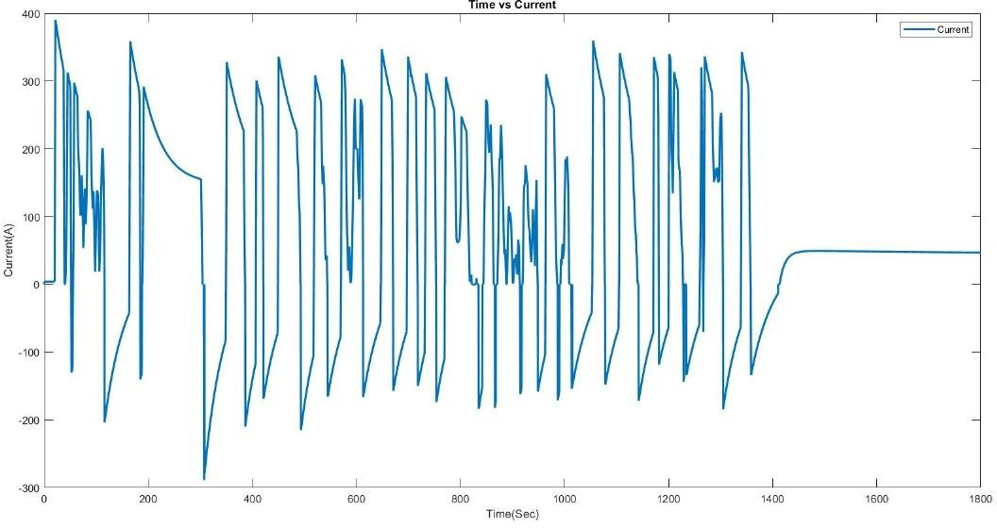

*Fig.4.7. Time vs. Current*

"Time vs. current" is a concept relevant in various contexts, particularly electronics. Here's how they relate:

* Time: Represents the duration for which something happens, often measured in seconds, minutes, hours, etc.
* Current: The flow of electric charge through a conductor, typically measured in amperes (Amps).

The relationship between time and current depends on the situation:

1. Battery Discharge: Imagine a graph with time on the x-axis and current on the y-axis. As a battery discharges over time (x-axis increases), the current it can provide (y-axis) might decrease. This is because the battery's internal chemistry limits the flow of electrons.
2. Circuit Analysis: In circuit analysis, time vs. current graphs can represent how current changes within a circuit over time. This can be due to various factors like:

* Switching Circuits: When a switch is turned on or off, the current flow changes rapidly, and the graph would show a sharp rise or fall.

1. Circuit Breaker Tripping: Circuit breakers protect circuits from overload. They have a time- current characteristic curve. This curve shows how long a breaker will take to trip (cut off current) depending on the amount of current exceeding the safe limit. Here, higher current (y- axis) leads to a shorter tripping time (x-axis).

Overall, time vs. current isn't a constant. It depends on the specific situation.

## Time vs. Voltage

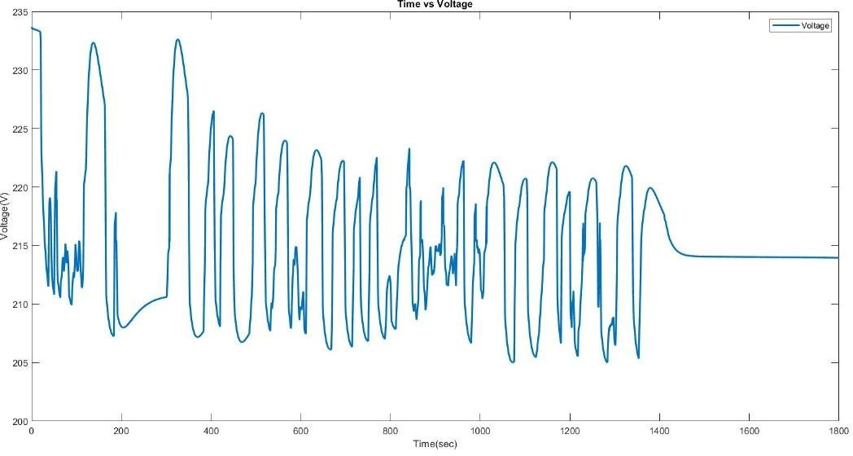

*Fig.4.8. Time vs. Voltage*

Time and voltage can be related in a few different ways in electrical circuits:

1. AC Voltage: In Alternating Current (AC) circuits, voltage constantly changes direction and magnitude over time. This variation is typically represented as a sine wave on a graph with time on the x-axis and voltage on the y-axis. The frequency of the AC voltage (cycles per second) determines how many times the voltage goes up and down within a second.
2. Voltage Transients: When a circuit is switched on or off, or experiences sudden changes, the voltage might not rise or fall instantly. Instead, it might take some time to reach its steady state. This temporary change in voltage over time is called a voltage transient.
3. Battery Discharge: Similar to time vs. current with battery discharge, the voltage a battery supplies can slightly decrease over time as it loses charge. However, this change is usually gradual compared to current and might not be very noticeable on a graph.
4. Voltage Regulation: Electronic circuits often have voltage regulators that maintain a constant voltage output even if the input voltage fluctuates slightly over time.

In contrast to time vs. current, time vs. voltage often deals with a range of voltages rather than a steady decrease. The specific relationship between time and voltage depends on the type of circuit and the electrical phenomena being observed.

## Time vs. Distance

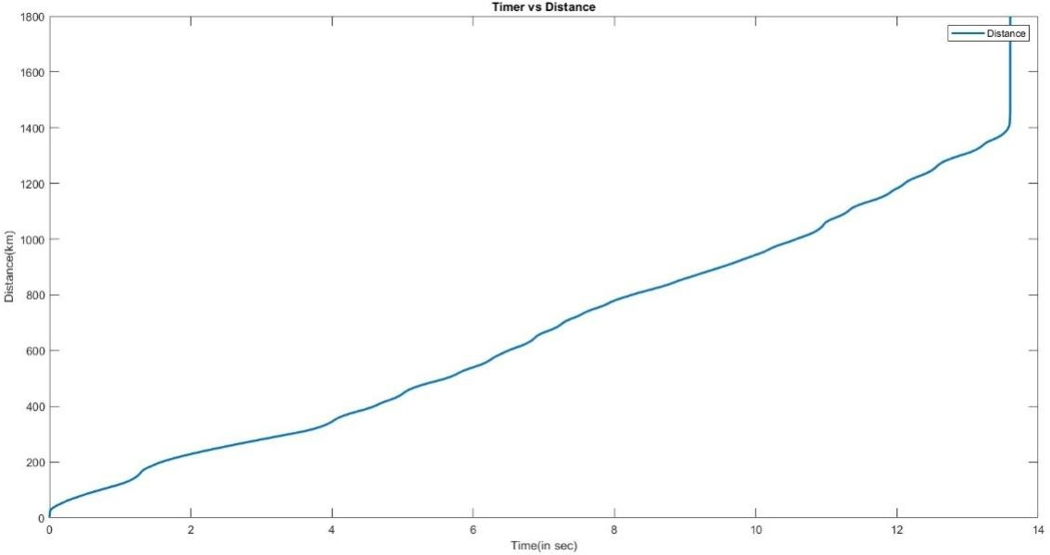

*Fig.4.9. Time vs. Distance*

In a battery electric vehicle (BEV), the relationship between time and distance is crucial for understanding the vehicle's performance, efficiency, and range. Here's an explanation of the time vs. distance relationship in a BEV:

1. Time: Time in the context of a BEV refers to the duration of operation or driving time. It represents how long the vehicle has been in operation, either continuously or over a specific period.
2. Distance: Distance refers to the amount of ground covered by the BEV during its operation. It measures how far the vehicle has traveled from its starting point, typically expressed in units such as kilometers (km) or miles (mi).

The time vs. distance relationship in a BEV can be understood through several key factors:

Energy Consumption: The energy consumption of the BEV affects its range and, consequently, the time vs. distance relationship. Higher energy consumption rates lead to shorter driving ranges, requiring more frequent recharging or shorter driving durations.

Battery Capacity: The capacity of the BEV's battery pack determines the maximum distance the vehicle can travel on a single charge. A larger battery capacity typically results in longer driving ranges and extended driving times before recharging is required.

## Time vs. Velocity

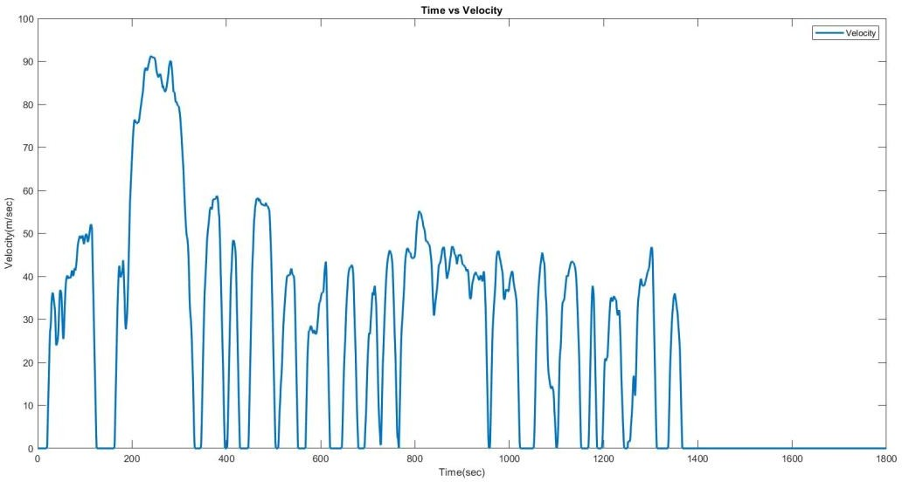

*Fig.4.10. Time vs. velocity*

In the context of a battery electric vehicle (BEV), the relationship between time and velocity (speed) refers to how the vehicle's velocity changes over time during different driving conditions or scenarios. Here's an explanation:

1. Acceleration: When a BEV starts from a standstill or accelerates, the velocity increases over time. This relationship is typically represented by a positive slope on a time vs velocity graph. The steeper the slope, the faster the acceleration of the vehicle.
2. Constant Velocity: During periods of constant velocity, the vehicle maintains a steady speed, and the velocity remains constant over time. On a time vs velocity graph, this appears as a horizontal line, indicating that the vehicle is not accelerating or decelerating.
3. Deceleration: When a BEV slows down or comes to a stop, the velocity decreases over time. This relationship is represented by a negative slope on a time vs velocity graph. The steeper the slope, the faster the deceleration of the vehicle.
4. Variable Velocity: In real-world driving scenarios, the velocity of a BEV may vary continuously over time due to factors such as traffic conditions, road gradients, and driver behavior. This results in a non-linear relationship between time and velocity, with fluctuations in velocity occurring throughout the driving period.

Understanding the relationship between time and velocity is crucial for analyzing the performance and efficiency of a BEV during different driving conditions. By studying the time vs. velocity graph, engineers and researchers can assess factors such as acceleration, deceleration, energy consumption, and overall driving dynamics to optimize the vehicle's design and operation for improved efficiency and performance.

**Benefits:**

Battery electric vehicles (BEVs) offer a number of compelling benefits over traditional gasoline-powered cars:

* Environmental benefits: BEVs produce zero tailpipe emissions, contributing to cleaner air and reduced greenhouse gas emissions. This is especially crucial in urban areas for improved air quality.
* Lower running costs: Electricity is generally cheaper than gasoline, and BEVs are significantly more efficient at converting energy to power the wheels. This translates to substantial savings on fuel costs.
* Reduced maintenance: BEVs have fewer moving parts compared to gasoline engines, leading to less wear and tear and potentially lower maintenance costs. No oil changes or spark plug replacements are needed.
* Performance: Electric motors deliver high torque output from a standstill, resulting in smooth, responsive acceleration and good hill-climbing ability.
* Quiet operation: BEVs are much quieter than gasoline vehicles, creating a more pleasant driving experience and reducing noise pollution.
* Government incentives: Many governments offer tax breaks and other incentives for purchasing BEVs, making them more affordable.

## Challenges and Considerations:

Range Limitations: BEVs typically have shorter driving ranges compared to conventional vehicles, which can be a barrier to adoption for some consumers.

Charging Infrastructure: The availability of charging infrastructure, including public charging stations and home charging facilities, is essential for widespread BEV adoption.

Charging Time: Charging times for BEVs can be longer compared to refueling conventional vehicles, although rapid charging technologies are being developed to reduce charging times.

Battery Life and Degradation: Battery degradation over time can affect the performance and range of BEVs, necessitating careful battery management and recycling strategies.

# CHAPTER 5 CONCLUSION

The combination of a Lithium-ion battery and a Permanent Magnet Direct Current (PMDC) motor proves to be a compelling choice for Battery Electric Vehicles (BEVs). Here's a summary of the key advantages:

* **Efficiency:** Lithium-ion batteries offer excellent energy density, allowing for longer range on a single charge. PMDC motors deliver high efficiency, converting most electrical energy into mechanical power for propulsion.
* **Performance:** PMDC motors provide high torque output at low speeds, resulting in smooth acceleration and strong hill climbing ability. This is ideal for urban driving environments.
* **Quiet Operation:** Both lithium-ion batteries and PMDC motors operate silently, contributing to a more pleasant driving experience and reduced noise pollution.
* **Simplicity:** The BEV drivetrain with this combination has fewer moving parts compared to internal combustion engines, leading to potentially lower maintenance costs.
* **Charging Infrastructure:** Widespread availability of charging stations is crucial for widespread BEV adoption.

**In conclusion,** the lithium-ion battery and PMDC motor combination offers a promising solution for BEVs. With continued advancements in battery technology, charging infrastructure, and cost reduction, BEVs powered by this combination are poised to play a major role in the future of sustainable transportation.

**Output values:**

SOC : 64.76 %

Current : 46.99 amps Voltage : 214 volts Distance : 13.6 km Velocity : 0.001654m/s

# References

1. Ates, M.N. et al., “In Situ Formed Layered-Layered Metal Oxide as Bifunctional Catalyst for Li-Air Batteries”, Journal of the Electrochemical Society, Vol 163, No. 10, 2016, pp.

A2464-A2474

1. Ates, M.N. et al., “In Situ Formed Layered-Layered Metal Oxide as Bifunctional Catalyst for Li-Air Batteries”, Journal of the Electrochemical Society, Vol 163, No. 10, 2016, pp.

A2464-A2474

1. Khajepour, A., S. Fallah and A. Goodarzi. 2014.Electric and Hybrid Vehicles Technologies, Modelingand Control: A Mechatronic Approach., Chichester,UK: John Wiley and Sons Ltd.
2. Nunes, P., M.C. Brito and T. Farias, “Synergies between electric vehicles and solar electricity penetrations in Portugal,” 2013 World Electric Vehicle Symposium and Exhibition, 2013, pp. 1-8. [5] C Clint, J., B. Gamboa, B. Henzie, and A. Karasawa. 2015. “Considerations for Corridor Direct Current Fast Charging Infrastructure in California.”
3. Chan, C.C., Jiang, J.Z., Chen, G.H., and Chau, K.T., Computer simulation and analysis of a new polyphase multipole motor drive. IEEE Transactions on Industrial Electronics, Vol. 40, 1993, pp. 570-576.
4. Zhan, Y.J., Chan, C.C., and Chau K.T., A novel sliding-mode observer for indirect position sensing of switched reluctance motor drives, IEEE Transactions on Industrial Electronics, Vol. 46, 1999, pp. 390-397.
5. B Smith, M. and J. Castellano. 2015. “Costs Associated with Non-Residential Electric Vehicle Supply Equipment.”
6. Mwasilu, F. et al., “Electric vehicles and smart grid interaction: A review on vehicle to grid and renewable energy sources integration”, Renewable and Sustainable Energy Reviews, Vol. 34, 2014, pp. 501-516

**1**

# International Journal of Research Publication and Reviews

Journal homepage: [www.ijrpr.com](http://www.ijrpr.com/) ISSN 2582-7421

# Design and simulation of Battery electric vehicle using

**MATLAB Simulink**

***Buddepu Harika1, G.Chandra Sekhar2, Burla Manikanta3, Baratam Ashish4 ,Bommali Manasa5, Gollangi Praveen6***

***1,3,4,5,6 Student at GMR Institute of Technology***

***2 Professor at GMR Institute of Technology***

Electrical and Electronics Engineering Department, GMR Institute of Technology, Rajam, Andhra Pradesh, India

**ABSTRACT:**

More and more researchers are focusing on the modeling of electric vehicles. One of the most important problems the world's ecosystems are currently confronting is the decrease of greenhouse gas emissions and energy consumption. Even if the actual trajectory of energy is uncertain, we believe that transportation will play a critical role in maintaining it. This study used the MATLAB-Simulink platform to simulate a BEV model and evaluated the various components of the BEV system. MATLAB-Simulink is utilized in this project to develop the BEV components and integrate the entire system. The outputs of this design are the voltage, current, and state of charge values. The car will describe how much energy is discharged when it is traveling and provide information about current and voltage in this project, which is based on voltage, current, and state of charge bases. It was also utilized to simulate the BEV model and related formulas. The required electrical system parts were also identified, along with the corresponding equations for validation. In order to reduce greenhouse gas emissions, we suggested in this project to model the demand for BEVs in the transportation sector going forward. The first step in modeling this is to understand the properties of the parameters and select the appropriate ones for MATLAB simulation of each component. We are also modeling a single app.

**Keywords: -** Battery Electric Vehicle, MATLAB-Simulink, Simulation, Energy consumption

* 1. **Introduction**

An electric vehicle (EV) is a vehicle type that runs on electrical energy stored in rechargeable batteries or other energy storage devices. It employs one or more electric motors for propulsion. Electric cars primarily run on electricity, as opposed to traditional internal combustion engine vehicles, which burn fossil fuels to provide power. The automotive industry is undergoing a significant transformation, driven by the increasing concerns over environmental sustainability and the need to reduce greenhouse gas emissions. In response to these challenges, there has been a growing interest in the development and adoption of electric vehicles as a cleaner and more sustainable alternative to traditional internal combustion engine vehicles. Among various types of electric vehicles, Battery electric vehicles (BEVs) have gained considerable attention due to their emission operation and potential to significantly reduce dependence on fossil fuels. BEVs rely solely on electric propulsion, utilizing rechargeable batteries as their primary source of energy. This reliance on electricity makes BEVs an attractive option for reducing carbon emissions, particularly when powered by renewable energy sources. The development and optimization of BEVs heavily relies on their design and simulation. The development of simulation tools such as MATLAB Simulink has allowed engineers and researchers to precisely simulate diverse BEV systems and components in order to evaluate how well they function under various operating situations. Before actual prototypes are constructed, this enables iterative design optimizations and upgrades, thereby cutting down on development time and expenses. In this research, we use MATLAB Simulink to build and simulate a battery-electric car. Our goal is to give a thorough rundown of the modelling procedure, including important elements such the electric motor, battery pack, power electronics, and vehicle dynamics.

* 1. **Literature Survey**

The articles concentrate on the analysis and optimization of battery-electric vehicles (BEVs) using mathematical modelling, simulation-based parameter evaluations, and energy consumption analysis. They seek to determine the best setups and settings in order to improve BEV performance, efficiency, and sustainability. Without doing a lot of actual testing, researchers investigate ways to increase battery efficiency, range, and overall vehicle performance using simulations and mathematical models. These studies offer insightful information that will help advance BEV technology and advance environmentally friendly transportation.

A thorough review of the literature on battery electric vehicle (BEV) design and simulation addresses a number of important topics. Scholars delving into battery technology investigate cutting-edge lithium-ion chemistries such as LiFePO4, NCM, LMO, and NCA, in addition to modelling approaches including physics-based, equivalent circuit, and electrochemical models. Studies of vehicle architecture cover a wide range of designs, such as platform-based, purpose- built, and hybrid setups, with an emphasis on powertrain components including motor choice and heat management systems that are optimized. The goal of energy management research is to reduce consumption and increase driving range by using optimization-based techniques and predictive control algorithms. Vehicle dynamics and performance are modelled with the help of simulation programs such as MATLAB/Simulink, AVL Cruise, and OpenModelica. This modelling is essential for assessing energy economy, braking, and acceleration. A crucial component of BEV integration is the smart charging infrastructure and electric grid impact analysis; studies have focused on vehicle-to-grid (V2G) technology, optimization for mass deployment, and grid impact analysis. The utilisation of this multifaceted approach enables a more profound comprehension and progression of BEV design and simulation techniques.

**2**

* 1. **Block Diagram :**

Driver Input

Controller

Motor

Battery

* 1. **Modelling operating principles of EV :**

Gear Box

Tires

Differentiator

The BEV and its components were recreated to investigate energy flow, performance, and efficiency. MATLAB-Simulink shows battery voltage, current, and state of charge information. The goal is to optimize the battery's voltage, current, potency, state of charge, and component size while minimizing energy consumption using modelling and simulation.

1.Vehicle Longitudinal Dynamics:

The longitudinal dynamics of a Battery Electric Vehicle (BEV) refer to the forces and motions that cause the vehicle to accelerate and decelerate along its route of travel. This covers things like traction force, air resistance, rolling resistance, and braking force. Understanding these dynamics is critical to improving the vehicle's performance, energy efficiency, and overall driving experience. For example, longitudinal dynamics have a considerable impact on the vehicle's range, which is a major concern for BEVs due to limited battery capacity. The longitudinal dynamics are influenced by factors such as vehicle mass, aerodynamics, tire properties, and electric powertrain efficiency.

𝑀 𝑑𝑦 = (𝐹

+𝐹 )-(𝐹

+ 𝐹

+ 𝐹

+ 𝐹

) ……………………(1)

𝑑𝑥

𝑡𝑓

𝑡𝑟

𝑟𝑓

𝑟𝑟

𝑎𝑑

ℎ𝑐

where M is the vehicle mass, 𝑑𝑦 is the linear acceleration of the vehicle along the longitudinal direction. 𝐹

and 𝐹

is the traction force of the front and rear

𝑑𝑥

𝑡𝑓

𝑡𝑟

tires, 𝐹𝑟𝑓 𝑎𝑛𝑑 𝐹𝑓𝑓s the rolling resistance force of the front and rear tires, 𝐹𝑎𝑑 is the aerodynamic drag force and 𝐹ℎ𝑐 is the hill climbing force. 2.Motor model

There are many ways to measure motor speed, including instructions and voltage. The equation clearly indicates that it is an input to the motor controller.

𝑊𝑣 = 𝛼𝑈 + 𝑏

Where U is the characteristic curve that approximates a line, V is the motor speed regulation instruction voltage, and a and b are the equation coefficients that differ with the motor load.

The motor model is based on a dc motor with a stiff rotor and shaft. Friction torque is proportional to shaft angular velocity.

𝑑2𝜃 = 1 (𝐾 𝑖 − 𝑏 𝑑𝜃) ……………………………..(2)

𝑑𝑡2

𝐽 𝑡

𝑑𝑡

𝑑𝑖 = 1 (−𝑅𝑖 + 𝑉 − 𝐾 𝑑𝜃) …………………………(3)

𝑑𝑡 𝐿

𝑒 𝑑𝑡

here 𝑑𝜃 is the angular velocity, 𝑑2𝜃 is the angular acceleration, 𝑑2𝜃 is the moment of inertia, b is the motor viscous friction constant, 𝐾 is the motor torque

𝑑𝑡

𝑑𝑡2

𝑑𝑡2 𝑡

constant, 𝐾𝑒 is the electromotive force constant.



The DC motor model depicts the motor's electromechanical characteristics. This encompasses torque-speed characteristics, efficiency, and power output. Typically, DC motors are represented by equations that characterize their electrical and mechanical characteristics.

3.Battery Charge Controller Mode:

The longevity of the batteries is due to this tool. It is crucial for developing the electric system of a BEV with an efficient Battery Management System (BMS). The State of Charge (SoC), measurement, cell balancing, battery voltage, current, and temperature are all displayed by the BMS. This model covers a basic battery pack and is based on the IRIZ battery.

The battery's overall charge is simply deducted from the motor's current draw. Next, the battery's voltage output is obtained using a typical discharge graph plot. The charge state (SOC) is

𝑆𝑂𝐶 =

**3**

𝐶𝑚𝑎𝑥 − 𝐶𝑢𝑠𝑒𝑑

𝐶𝑚𝑎𝑥

Vehicle Parameters:

Electric The vehicle design parameters in might be divided into three categories: (1) vehicle parameters, (2) electric element parameters, and (3) environment parameters. Vehicle parameters comprise information regarding the mass, rolling resistance, frontal area, drag coefficient, brake and steering forces, and tire specifications of the vehicle. The inclination angle, wind speed, and tire inflation factor are included in the environmental parameters, while the features of the electric motor, battery pack, motor controller, and battery charger are included in the electric elements.

**Circuit Diagram:**

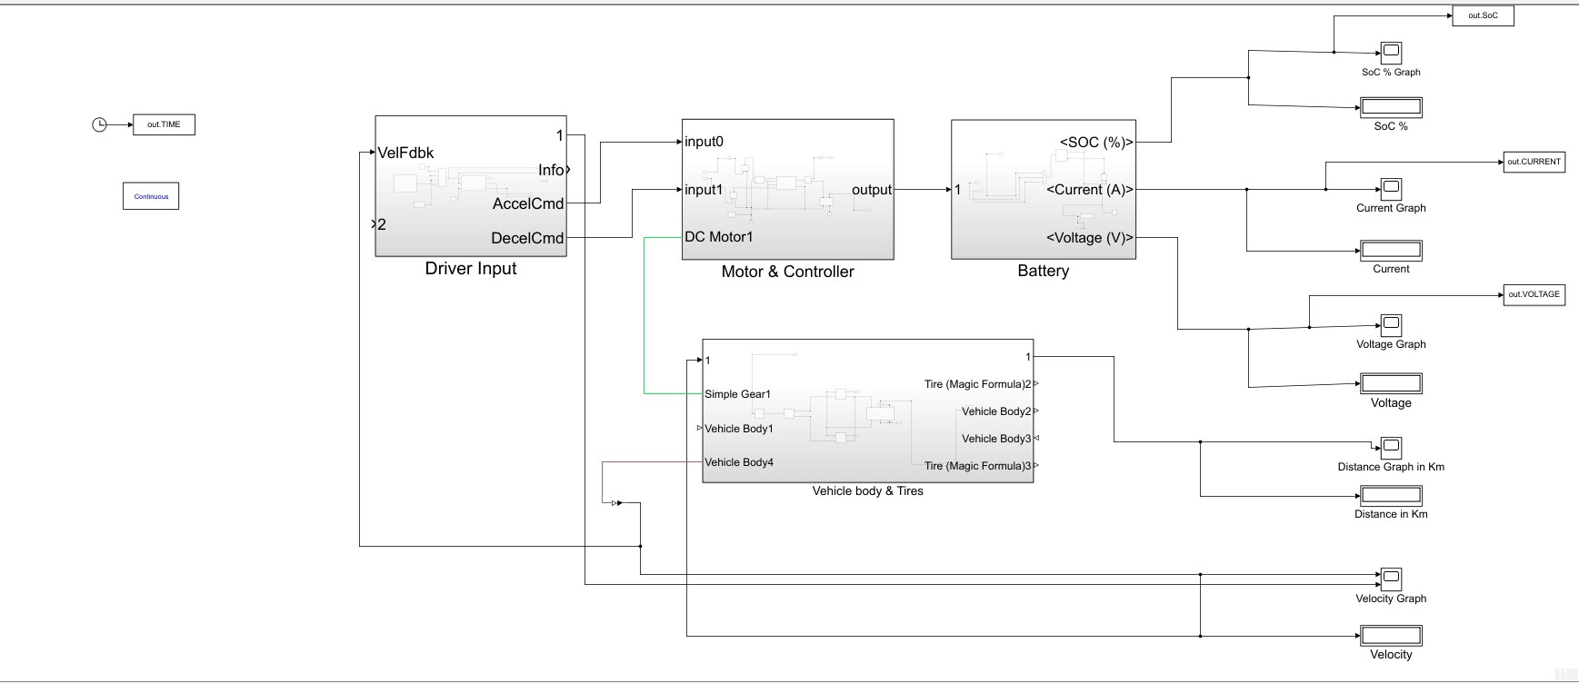

Fig 1 . Circuit Diagram

This circuit diagram explains the working of battery electric vehicle by using battery voltage, current and state of charge.

**Simulation Results:**

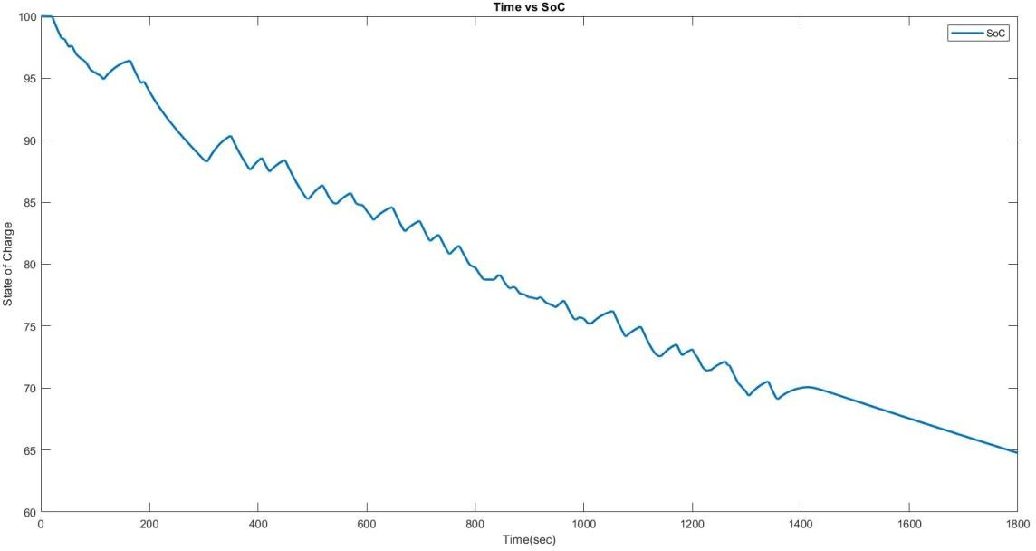

Fig 2 FTP-75 we gave 1800 seconds State of Charge graph

**4**

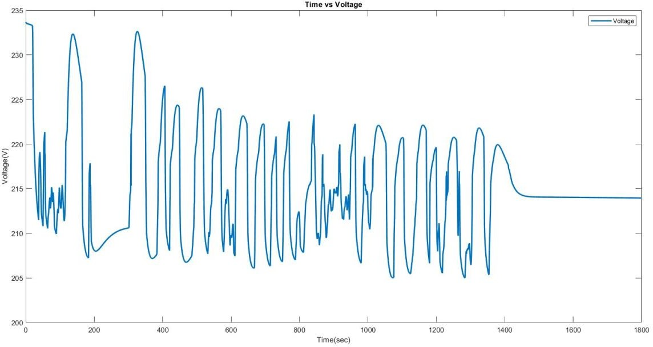

Fig 3 FTP-75 we gave 1800 seconds Voltage graph

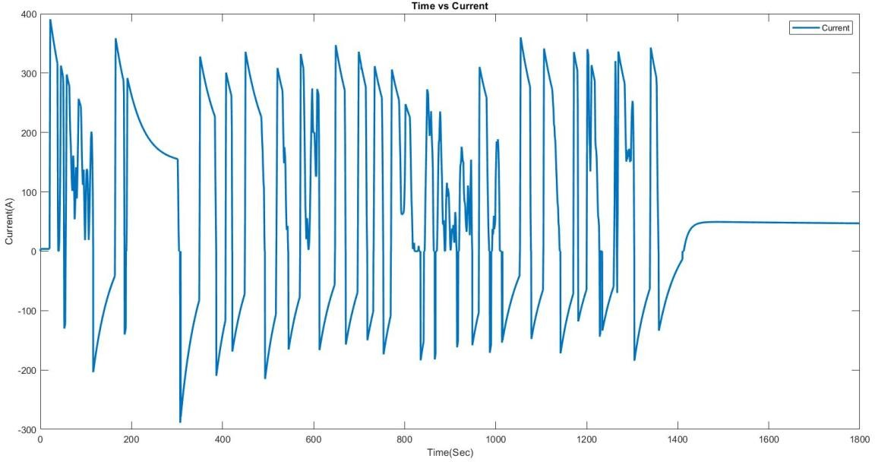

Fig 4 FTP-75 we gave 1800 seconds Current graph

**Working Of Lithium-ion Battery :**

The lithium-ion battery works on the basis of circulating electrons through the creation of a potential difference between two electrodes, one positive and the other negative, submerged in an electrolyte, a conductive ionic liquid. The discharging phase occurs while a battery is powering a device because the electrons built up in the negative electrode are released to move to the positive electrode via an external circuit. On the other hand, when the battery is being charged, the electrons are transferred from the positive electrode to the negative by the energy provided by the charger.

The various battery types differ in terms of the associated electrolytes, electrode materials, and ion kinds. For instance, the 12-volt lead-acid battery that is typically used to power a car's combustion engine starter depends on lead-based electrodes and an electrolyte that contains lead ions. Regarding the lithium- ion battery, its nomenclature comes from the fact that it operates on lithium ions (Li+). A lithium-ion battery, like the one found in the ZOE, is made up of several battery units, or cells, that are coupled to one another and are under the control of a certain electronic circuit. The battery's capacity, or the total quantity of electricity it can store, is determined by the number, size, and arrangement of its cells as well as the voltage it delivers. In the automotive sector, this is typically expressed in watt-hours (Wh) or kilowatt-hours (kWh).

**5**

**Methodology:**

Battery electric vehicles (BEVs) require several critical stages for modelling and simulation. Gather data first on the characteristics of the battery, the motor's efficiency, and the vehicle's dynamics. Next, develop mathematical models that show how these parts behave while accounting for factors like vehicle mass, powertrain efficiency, and energy consumption. These models can be included into simulation software to replicate real-world driving conditions and evaluate performance metrics like range, acceleration, and energy usage. Cross-check the simulation results with empirical data from real tests to ensure correctness. Iterate and update the models in response to validation feedback to enhance their predictive power. Utilize environmental details like temperature and terrain to increase realism even further. Lastly, use the validated simulation tool for a range of activities such as calculating the ideal battery size, assessing increases in vehicle economy, and developing control schemes for the best possible energy management.

**Conclusion:**

The report underscores the critical importance of addressing climate change by reducing energy consumption and greenhouse gas emissions. It highlights transportation as a key sector for achieving sustainability goals and emphasizes the urgent need for action. MATLAB-Simulink emerges as a powerful tool for modeling. Battery Electric Vehicles (BEVs), enabling the creation, integration, and detailed analysis of BEV components. Through simulations, the program provides valuable insights into the performance of BEV systems, with outputs such as voltage, current, and state of charge data offering crucial information on energy usage and battery performance. By leveraging MATLAB-Simulink, researchers can better understand the complexities of BEV technology and make informed decisions to advance sustainable transportation solutions in the face of climate change challenges.

**Reference:**

[1] Husain, I. 2003. ELECTRIC and HYBRIDVEHICLES Design Fundamentals., New York, USA:

CRC Press.

[2]. A.T. Mohd1, M.K. Hassan1, 2, IshakAris1 , A.Che Soh1 ,B.S.K. K.Ibrahim3 ,and M.K.Hat3 1Department of Electrical and Electronic Engineering, Faculty of Engineering,Universitiy Putra Malaysia, Serdang,Selangor,Malaysia 2 Institut Teknologi Maju, Universiti Putra Malaysia, Serdang,Selangor,Malaysia.

1. TA.T. Mohd1, M. K. Hassan1,2 and WMK.A. Aziz1 1Department of Electrical and Electronic Engineering Faculty of Engineering, Universiti Putra Malaysia 43400 Serdang, Selangor, Malaysia Schaltz, E. 2011. Electrical Vehicle Design and Modeling, in Electric Vehicles - Modelling and Simulations, S. Solyu, (Editor), In Tech.
2. Larminie, J. and J. Lowry. 2003. Electric VehicleTechnology Explained. Chichester, UK: John Wiley and Sons, Ltd.
3. Khajepour, A., S. Fallah and A. Goodarzi. 2014.Electric and Hybrid Vehicles Technologies, Modeling and Control: A Mechatronic Approach., Chichester,

UK: John Wiley and Sons Ltd.

1. ] Tuffner, F. and M. Kintner-Meyer, Using Electric Vehicles to Meet Balancing Requirements Associated with Wind Power, U.S. Department of Energy Pacific Northwest National Laboratory, 2011
2. B Smith, M. and J. Castellano. 2015. “Costs Associated with Non-Residential Electric Vehicle Supply Equipment.”
3. C Clint, J., B. Gamboa, B. Henzie, and A. Karasawa. 2015. “Considerations for Corridor Direct Current Fast Charging Infrastructure in California.”
4. Chan, C.C., Jiang, J.Z., Chen, G.H., and Chau, K.T., Computer simulation and analysis of a new polyphase multipole motor drive. IEEE Transactions on Industrial Electronics, Vol. 40, 1993, pp. 570-576.
5. Zhan, Y.J., Chan, C.C., and Chau K.T., A novel sliding-mode observer for indirect position sensing of switched reluctance motor drives, IEEE Transactions on Industrial Electronics, Vol. 46, 1999, pp. 390-397.
6. Nunes, P., M.C. Brito and T. Farias, “Synergies between electric vehicles and solar electricity penetrations in Portugal,” 2013 World Electric Vehicle Symposium and Exhibition, 2013, pp. 1-8.
7. Mwasilu, F. et al., “Electric vehicles and smart grid interaction: A review on vehicle to grid and renewable energy sources integration”, Renewable and Sustainable Energy Reviews, Vol. 34, 2014, pp. 501-516
8. Ates, M.N. et al., “In Situ Formed Layered-Layered Metal Oxide as Bifunctional Catalyst for Li-Air Batteries”, Journal of the Electrochemical Society, Vol 163, No. 10, 2016, pp. A2464-A2474